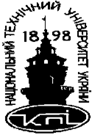 National Technical University of Ukraine

«Kyiv Polytechnic Institute of Igor Sikorsky»

APEPS Department

COURSEWORK

Made by : Edward Sikolenko, TM-01mp

Checked by: Anatol Demchyshyn

__________________________

**MAIN TASK**

Main task of this coursework is to understand how to calculate and visualize tangents and a normal to a point lying on the surface.

The surface named Astroidal Tours (according to my variant) and the formula for it’s building, is shown at the picture 1.

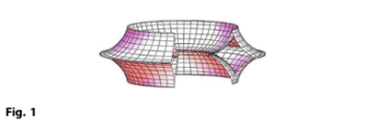  
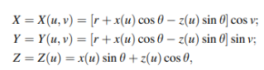  
  
Picture 1 – surface and it’s formula

**THEORY**

For N-dimensional coordinate system we can find (N-1) tangent vectors. To do this we should solve several mathematic equations shown at the picture 2.

$$\overline{u}=\left(\frac{dx}{du}, \frac{dy}{du},\frac{dz}{du}\right); \frac{dx}{du}= \frac{F\left(u+ ∆u,v\right)-F\left(u, v\right)}{∆u}$$ Picture 2 – mathematic equation for tangent vector

To find normal vector we should find cross product of our tangent vectors. This can be easily found by matrix, shown at the picture 3.

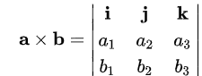  
Picture 3 – matrix to find cross product

**IMPLEMENTATION**

To solve the problem of my coursework I used three js library. It is easy to render our surface using ParametricGeometry class. All we need to do is to implement function that will solve the equations from the picture 1. Then we add several point lights to out scene.

To calculate tangent and normal vector I created function called “calcVector” and implemented equations from pictures 2 and 3.

To visualize vectors I used ArrowHelper class. I also added event listener to change current point position.

**SCREENSHOTS**

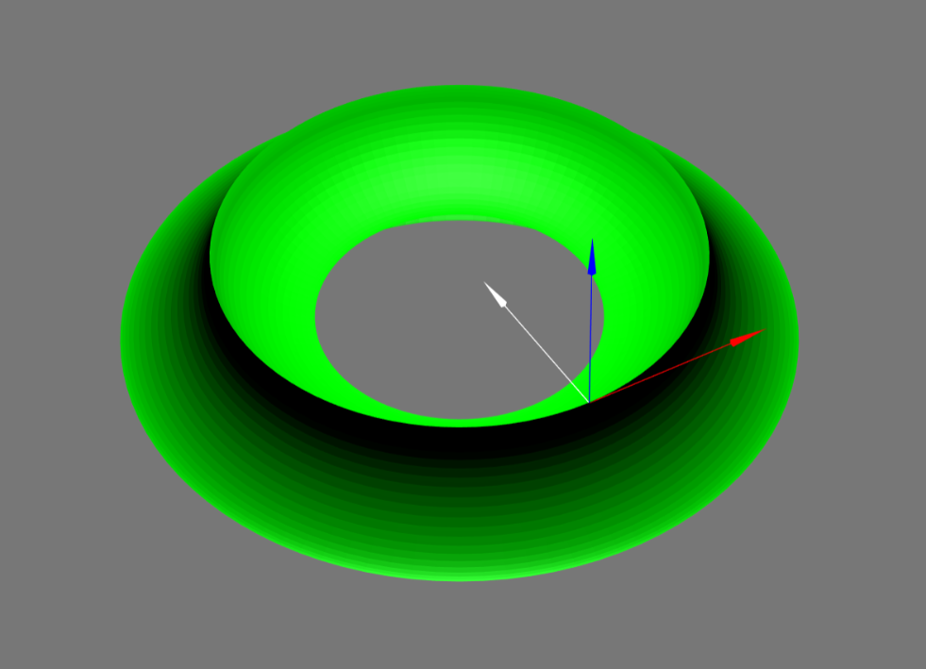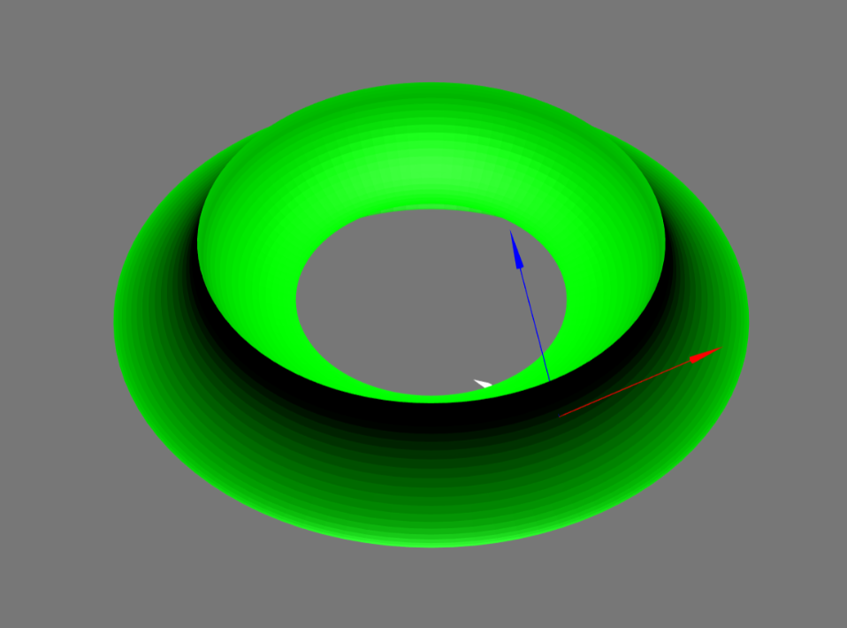

**CODE SAMPLE**

